

Trackmatic

Integration Requirements Specification Document

Table of Contents

What we do 3

Types of services we offer 4

How to integrate with us? 5

Step 1 5

Types of connections 5

1. Web service request to Azure 5

2. Polling Listener 6

3. SFTP/FTP 7

4. Flat file Listener 8

5. Email Listener 9

Step 2 10

Basic questions and information from client 10

Step 3 11

Specific fields required for integration 11

Action 11

Entity 12

Deco 12

Routes 13

Handling Units 13

# What we do

In short, Trackmatic provides unique tailor-made software solutions to fleet operators and fleet management of On-Road Execution™ regardless of the fleet size.

We offer a holistic business solution to our clients, meeting their unique and complex requirements. We work together with them to provide insight into the finer workings of their operations, thereby increasing efficiencies and enabling greater levels of satisfaction among their customers.

Resource optimisation and service excellence are key outcomes of the solution, resulting in higher profits and driving down costs. This is where the true value of the solution is gained.

The table following summarises our solutions.

## Types of services we offer

|  |  |  |  |  |
| --- | --- | --- | --- | --- |
| On-Road ExecutionTM | Planning | Bureau | Insight | Mobility |
| Live Visibility | Backend Integration | On Road Execution Control Room | KPI Management | Turn by Turn Voice Guided Navigation |
| Historical Tracking | Route Builder | Full Audit | Planned vs Actual | Voice Calls |
| Advanced Delivery Notifications | Route Updates | DECO Management | Trending | Sign-on Glass Confirmation |
| Live Dashboards | Licensed Planning Algorithms | Voice Recordings | Driver Alignment |  |
| Risk Management | Third Party Planning Tools | Exception Based Alerts | Customised Automated Reporting |
| Speed Management | Data Integrity |  |  |

# How to integrate with us?

To integrate and make use of Trackmatic’s services, simply complete and follow the four steps below.

## Step 1

## Types of connections

It is vital for the client to pay special attention in the choice you make to connect to us. The client should base their choice primarily on ease of use and efficiency to improve business feasibility as well as maintain data integrity.

There are five main methods of connecting to Trackmatic:

#### Web service request to Azure

The client presents the required data to our web service in XML or JSON. Upon receiving it, it is then mapped and uploaded into Trackmatic.

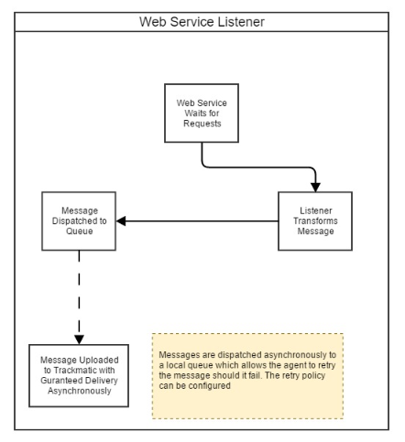

#### Polling Listener

This is installed as a service on the client’s local server or machine. It listens to a 'Trackmatic-Changes' table placed within the client’s database. This table records all the changes been made to the relevant client’s tables needed to use Trackmatic’s services. These changes in relation to the tables are then traced, picked up and updated in Trackmatic.

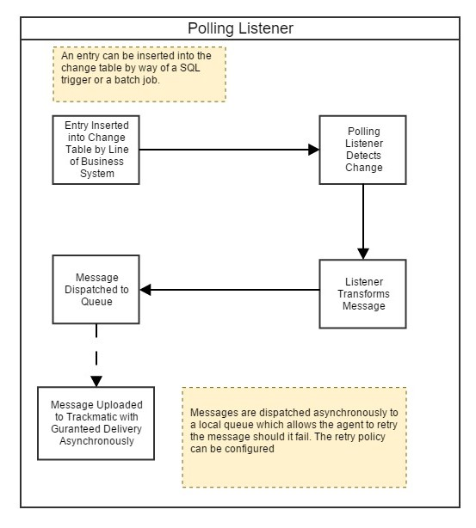

#### SFTP/FTP

The client drops an excel extract (CSV) to the SFTP/FTP server containing all the relevant data to use Trackmatic services. The integration agent polls the directory of the SFTP/FTP for the file. If an extract is picked up, it is then read in and uploaded into Trackmatic. The client can choose to use their own SFTP/FTP server (preferable) or Trackmatics SFTP/FTP server.

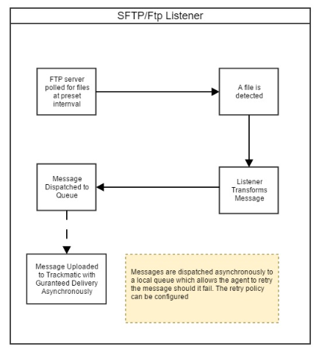

#### Flat file Listener

Very like SFTP/FTP, the client drops an excel extract (CSV) containing all the relevant data to use Trackmatics services onto a local directory in Trackmatic’s server. The integration agent which is running on Trackmatic’s server will poll the directory for the file. If an extract is picked up, it is then read in and uploaded into Trackmatic.

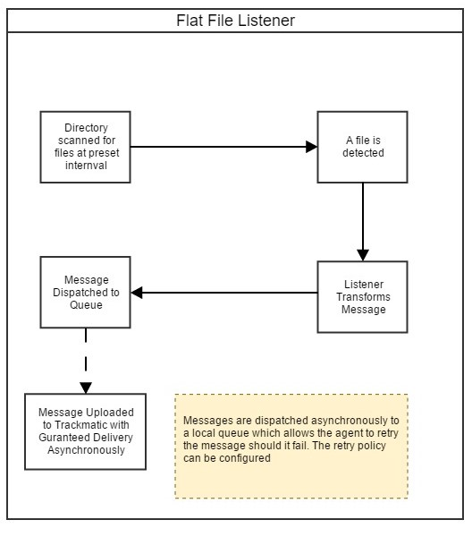

#### Email Listener

The client emails an excel extract (CSV) containing all the relevant data to use Trackmatic’s services to an email address provided by Trackmatic. The integration agent which is running on Trackmatic’s server will then pick up this email. If an extract is picked up within the email, it will then be read in and uploaded into Trackmatic.

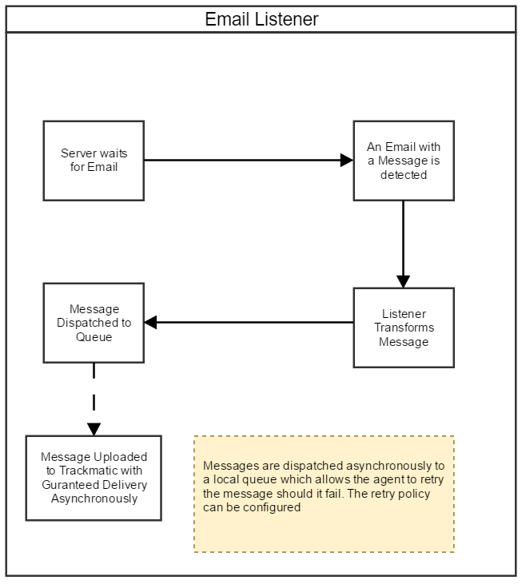

## Step 2

### Basic questions and information from client

Below are some questions and basic information that a client will be inquired about and expected to provide to Trackmatic.

Questions

* Are the Ship -To addresses *ad hoc* or Static?
* Are the Start and End locations for the delivery vehicles the same?
* Do you facilitate next day deliveries?
* Do you facilitate for cash on deliveries?
* Do you provide any of the following services: Inter-branch transfers, uplifts, customer to collect?
* How many sites do you service (Isando, Kempton park, East Rand etc.)?

Information

* Contact details of the technical and business people involved in facilitating the integration.
* Sample data from the client’s business. Documentation like as invoices, waybills, delivery notes, trip sheets (all paper work the driver requires) etc. This should be provided in excel (csv) format as well as the physical copies of the documentation.
* If Trackmatic needs to integrate with external systems, then Trackmatic will need to be provided with the details for the systems. For example, IP addresses, port numbers, logon credentials and firewall rules.

## Step 3

### Specific fields required for integration

The fields below per section, if provided, can be created within Trackmatic.

An example for each section has been provided for clarity.

Please note that not all fields are mandatory unless specified in the second column.

#### Action

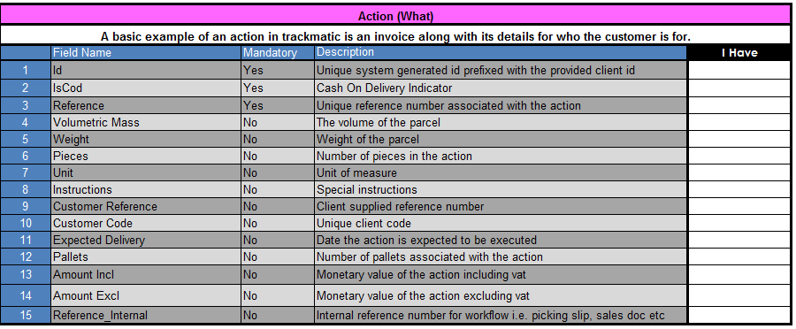

#### Entity

#### Deco

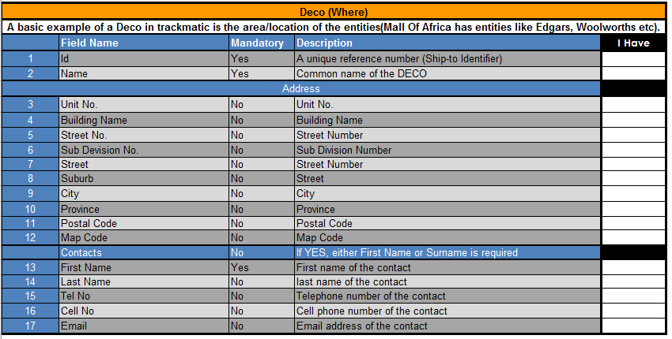

#### Routes

NB: An entity, deco and action should be specified for each route.



#### Handling Units

NB: This is optional functionality and can be of use if the line of business supports it.

